***CAMPUS RECRUITMENT TRAINING***

***CONTENT DEVELOPMENT***

***PERSONALITY GROOMING***



**MAP EDUCATORS**

**LEARNING TODAY, LEADING TOMORROW**

***PLACEMENT WORKSHOP***

***EXAMINATION CONSULTING***

***WHO WE ARE???***

***MAP Educators*** is a team of professional trainers who are highly experienced in providing quality soft skills and personality development training. In our short journey of four years we were fortunate to train a large number of students from various Colleges and Universities.

Our Programs intended for Aptitude & Personality Development are designed to fulfill the needs of various employability exams like eLitmus, co-cubes, iPAT, AMCAT, [NASSCOM NAC-TECH](http://nactech.nasscom.in/web/indiamap.aspx) etc.

Apart from this, through rigorous research and close analysis of previous year examinations at national level, we have developed a content database which is highly beneficial to any student who seeks to become an efficient professional irrespective of corporate or government sector.

***PREPARATION INTENSITY***

Our course structure is designed for the optimum delivery while focusing on conceptual clarity, speed and accuracy resulting in peak performance.

***3600 CAREER DEVELOPMENT***

Our comprehensive & proven course material along with regular workshops covers every aspect of preparation. This learning is carried forward in their attitude and careers.

***PERSONALIZED MENTORING***

One-to-one regular interactions and feedback sessions with our expert mentors and faculties offers an unparalleled test preparedness and hand-holding for career guidance.

***FULL -TIME EXPERT FACULTY***

With full-time expert faculty specially equipped to handle career and exam preparation related questions, you can rest assure you are in safe hands.

It is exclusively designed for the students preparing for recruitment and is geared towards ensuring that the students are well equipped to get through the process of various IT and Non-IT companies by gathering the inputs from Job-seekers and Placement providers.

***CAMPUS***

***RECRUITMENT***

***TRAINING***

Analyze and research exam patterns, types of questions and difficulty level to remain updated with latest trends in questions asked in competitive exams. Plan, develop and execute launch of new test series, in coordination with our team members.

***CONTENT***

***DEVELOPMENT***

***EXAMINATION***

***CONSULTING***

Seminars on importance of balanced preparation for competitive exams, other than Campus recruitment tests, conducted by various Government organizations. Making the students aware of all the patterns and nature of exams, and most importantly the strategy and the right approach to nail these exams.

***PLACEMENT***

***WORKSHOP***

Considering the vitality of personality in life, some necessary and result oriented tips are given. Developments of interaction skills, short and to the point way of communication, positivity in outlook, etc. are the key focus areas.

***PERSONALITY***

***GROOMING***

To prepare students to face job interviews & group discussions. Students are taught skills like resume writing, presentation skills and time management etc. Make students completely industry-ready by the time they complete their respective course.

***CAMPUS RECRUITMENT TRAINING PROGRAM***

***PROGRAMS UNDER CRT***

1. **INTENSIVE SEMESTER PROGRAM**

Program Highlights:

* 60 Hours of classroom based program.
* Detailed discussion of all the concepts of analytically segregated topics.
* All topics covered with the best possible tricks and shortcuts.
* Printed study material including 1000+ questions in class exercise and 2000+ questions in practice exercise.
* Complete discussion of class exercise covering all types of questions.
* Modern techniques for better understanding of complex topics like Cubes and Dice, Visual reasoning, etc.
* Pre-assessment and regular assessment tests with detailed analysis.
* Interactive doubt clearing session at the end of program.

1. **FAST TRACK PROGRAM**

Program Highlights:

* 35 Hours of classroom based program.
* Detailed discussion of questions of analytically segregated topics with the involved concepts.
* All topics covered with the best possible tricks and shortcuts.
* Printed review material (Topic wise) including 1000+ questions.
* Complete discussion of class exercise covering all types of questions.
* Pre-assessment and review test with detailed analysis.
* Modern techniques like video lectures for important topics to cover maximum topics.

1. **REFRESHER COURSE-CRT SPECIAL**

Program Highlights:

* 20 Hours of classroom based program.
* Special focus on questions asked by recruitment companies in previous years.
* Printed handouts created after deep analysis of previous year campus recruitment exams of Infosys, TCS, L&T, etc.
* Discussion of 500+ questions in class within stipulated time of 20 hours.
* Do’s and don’ts during campus recruitment test.

***HOW DOES THE INSTITUTE GET BENEFITTED???***

Placement is the buzz word among students of the present generation. Colleges are no longer making a name on the top list because of the quality education they impart instead the colleges that are providing best placements are hitting the chart of the student’s preferred colleges. Students are increasingly selecting colleges on the basis of the placements that the colleges are providing. They now want to get placed with a good package right after the completion of the course.

Our program is not just a gain for the students but can be an asset for the institute as well. Improvement in the placement records gives the institute an edge over the other institutes of the region. Students can utilize our program to excel in national and international level exams such as SSC, Banking, GRE, GMAT, CAT and GATE, etc. This creates an engaged, supportive alumni network crucial to the Institution’s success.

An engaged alumni network allows the institute to benefit from the skills and experience of its graduates, by offering their support to its students, to the institution and to each other. ***They are the best ambassadors, offering invaluable marketing and promotion across their personal and professional networks.***

***OUR BENEFITS TO YOU***

* **Result driven focus:** We take time to listen and to understand your needs and situation. That allows us to develop your students in the context of addressing your concerns. We use experiential education to enable solutions to the toughest problems.
* **Thought Partnership:** We bring to the table people with deep learning and industry experience, who work with you collaboratively to shape your students.
* **Innovation & Flexibility:** We draw on a broad range of learning methods and an extensive network of educators and industry experts across the world. We selects the elements that best matches your culture, challenges and budget and blend them into a fully integrated experience for the students and faculty.
* **Local Understanding & Global Insight:** Our perspective is global even though we ensure full understanding of our local network and needs of our clients. We operate by keeping local sensitivity in mind and produce the highest results thereby.

***OUR TEAM***

**Pratul Dhagat**

B.Tech (SRM University)

6+ Years Experience in CRT Training

Quantitative and Reasoning Aptitude

**Mr. Mondeep Kumar**

B.Tech (Central University,Chattisgarh)

4+ Years Experience in CRT Training

Quantitative and Reasoning Aptitude

**Mr. Gaurav Agarwal**

BDS (Subharti Medical College)

6+ Years Experience in CRT Training

Language and Verbal Aptitude

**Mr. Gaurav Bansal**

MBA (Delhi School of Economics)

6+ Years Experience in CRT Training

Quantitative and Reasoning Aptitude

**Mr. Mukesh kumar**

15+ Years Experience in CRT Training

Language and Verbal Aptitude

**Mr. Nitin Kumar**

B.Tech (PIET)

4+ Years Experience in CRT Training

Quantitative and Reasoning Aptitude

**Mr. Aatish Agarwal**

B.Tech (SIET)

3+ Years Experience in CRT Training

Quantitative and Reasoning Aptitude

***ASSOCIATED COLLEGES***

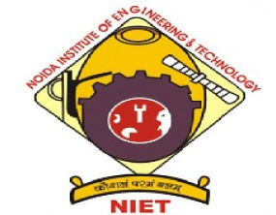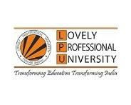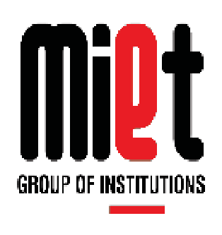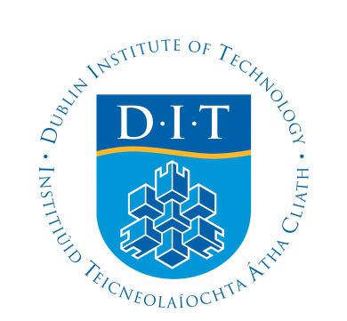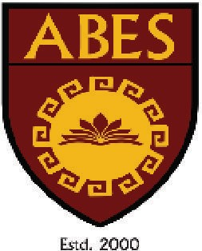

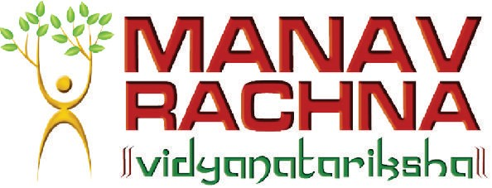

***CONTACT US***



REGISTERED OFFICE:

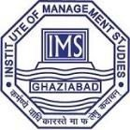

Flat No. 907, Pocket- D

Loknayakpuram

New Delhi- 110041

For More Information: Visit Us:

Call- 9650707558 mapeducators@xyz

9821209937

Email: info@mapeducators.xyz www.facebook.com/mapeducators